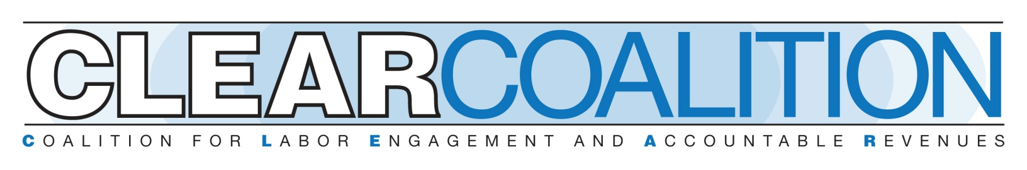

**Minimum Wage**

**It’s time to raise the wage**

* Pennsylvania’s lawmakers haven’t voted for a minimum wage increase since 2007.
* The current minimum wage of $7.25/hr is from a federal mandate in 2009
* Adjusted for inflation, the minimum wage is now worth less than at any time since the mid-1950s.
* Every bordering state has an hourly wage that is higher than Pennsylvania’s by at least $1.50 – and four of those states have a minimum wage of at least $15.
* A recent report by the Independent Fiscal Office analyzed the impact of raising the minimum wage from $7.25 to $15.00 per hour for nontipped workers and from $2.83 to $9.00 per hour for tipped workers on January 1, 2026. The IFO estimates that in May 2025, 83,000 PA workers will earn less than $11/hour and 401,000 PA workers – 6.7% of the total workforce – will earn less than $15/hour.

**Buying power is eroding**

* In 2006, a year before PA’s legislature raised the wage for the last time, the state’s minimum wage was 26% of the average wage – the lowest at any point since the federal minimum wage was first enacted in 1938. In 2023, it dropped to 22 percent of the average wage—a new all-time low—and is projected to fall to 21% of the average Pennsylvania wage in 2024, to 20% in 2025, and to less than 20% by 2026.
* Inflation adversely affects the purchasing power of an unchanging minimum wage. In 2009, the last year in which the minimum wage increased, the purchasing power of the minimum wage was $10.30 (in 2023 dollars) and has been steadily declining since then.
* The value of the 2024 minimum wage of $7.25 is projected to fall to $7.06 in 2025 and $6.87 in 2026 after adjusting for estimated inflation.
* The current Pennsylvania and federal $7.25 per hour minimum wage almost exactly matches the poverty wage of $7.24 per hour for a single individual—the minimum amount that a single individual working full time needs to earn per hour for 52 40-hour work weeks to reach a poverty income.

**PA workers are falling behind**

* In 2024, 30 states had higher minimum wage rates than Pennsylvania ranging from

$8.75 to $16.28 per hour.

* In 2024, there were seven states with minimum wage rates of at least $15.00 and an additional four states (including neighboring Delaware), are projected to join them in 2025.
* Most of the states with a higher minimum wage than Pennsylvania tie changes in their minimum wage to inflation rates of the Consumer Price Index or other similar measures to provide automatic increases that keep pace with inflation.
* A low statewide minimum wage suppresses wages for workers in the lowest earnings range, even when most of those workers aren’t paid above the minimum wage. In 2023, Pennsylvania’s 10th percentile workers earned $1.71 per hour less than their counterparts in New York, New Jersey, and Maryland. This amounts to a $3,567 per year difference for a full-time, year-round worker.
* Minimum wage increases in bordering states severely affect Pennsylvania's job competitiveness.

**We need a living wage**

* A living wage is what one full-time worker must earn on an hourly basis to help cover the cost of their family’s minimum basic needs where they live while still being self-sufficient.
* MIT’s Living Wage Calculator’s estimate of a living wage includes eight typical expenses or basic needs: food, chil care, health care, housing, transportation, civic engagement, broadband access, and other necessities.
* A minimum wage under $20 provides a living wage for single workers without children in only nine PA Counties.
* Allowing local control for minimum wage is key to ensuring that a living wage is possible throughout the state.

**Low wage workers/Local economic effects:**

* Low-wage workers often struggle to cover basic needs such as housing, healthcare, and education. They are forced to make difficult choices between paying bills and putting food on the table.
* This not only affects their quality of life but also hinders economic growth in the state. When workers are unable to meet their basic needs, it dampens their ability to contribute to local businesses and support the overall economy.
* Increasing the minimum wage puts more money in the hands of low-wage workers, who are more likely to spend it on essential goods and services in their communities. This increased spending can stimulate local businesses and support economic growth.
* People in some of the challenging jobs in difficult industries such as home care and childcare workers are the Pennsylvanians who would be helped by raising the minimum wage.

It has been 18 years since our Legislature acted on the minimum wage. It is time to take action to benefit all Pennsylvanians.