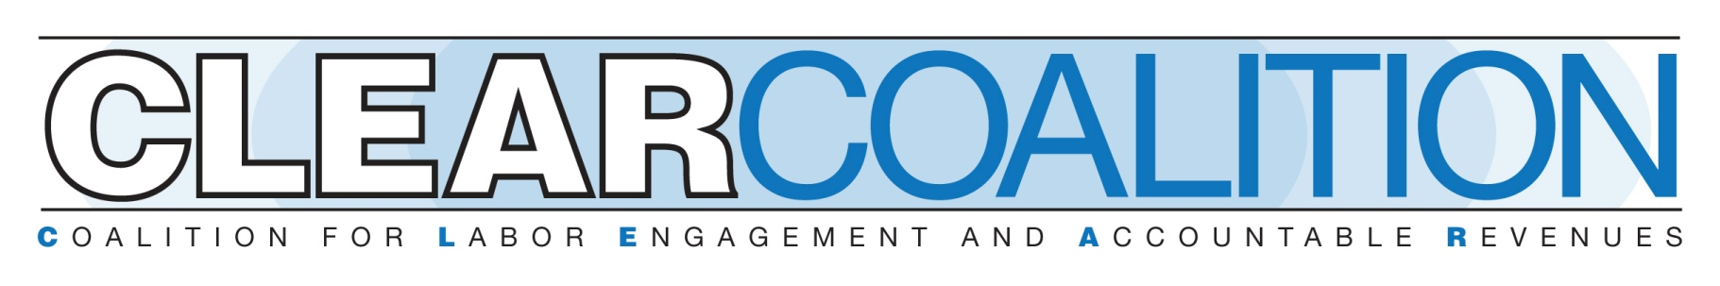

**Public Sector OSHA**

* OSHA covers most private sector workers in all 50 states through the OSH Act or through state plans. State plans are OSHA-approved job safety and health programs operated by individual states instead of Federal OSHA.
* State plans are required to meet at least the minimum requirements of the federal OSHA plans. 29 states and territories have plans that protect public sector workers.
* Public employees make up 12% of PA’s workforce; over 600,000 workers in 2019.
* According to the Bureau of Labor Statistics, the most dangerous jobs in Pennsylvania, measured by injury and death, include PennDOT workers, laborers, and other construction workers.
* State plans are funded up to 50% through Federal OSHA. OSHA approves and monitors all state plans.
* A recent study based on statistics from 2022 found that public sector workers are 81% more likely to get injured on the job compared to private sector workers.

**HB308 of 2025 – Public Sector OSHA Bill Analysis**

The proposed bill would apply OSHA standards to public employees/employers and the secretary of the Department of Labor (DOL) would have the authority to enforce such standards.

All public employers would have a duty to provide employees with a place of work: (1) which is free from hazards that are causing or likely to cause death or serious physical harm; and (2) which will provide reasonable and adequate protection to the lives, safety, and health of employees. Public employers also would be required upon request, to provide employees with a list of substances with which the employee comes into contact that are identified as toxic or hazardous under OSHA standards.

Under the legislation, the state would have to come up with a plan for the development and enforcement of OSHA standards for public employees/employers. The secretary of DOL would have the authority to promulgate regulations to administer and enforce the act and must, among other things provide for: (1) preparation, adoption, amendment, or repeal of workplace regulations; (2) methods of encouraging efforts to reduce safety hazards; (3) reporting procedures; (4) inspections without advance notice; and (5) publication and dissemination to employees/employers and unions of informational, educational, and training materials.

Public employers would have the authority to request a temporary variance from a standard which the secretary of DOL may only grant after providing notice to employees and an opportunity for a hearing.

The proposed bill would also establish a Pennsylvania OSHA review board to hear appeals of compliance orders issued by the secretary of DOL. A person adversely affected by a decision of the OSHA board of review, would have the right to judicial review of the order.

Regarding inspections, the bill would provide that the secretary or designee may obtain a warrant from the Commonwealth Court if they are denied access to a place of employment. In addition, a representative of the employer and of the union would have the right to accompany the secretary or designee on a workplace inspection. An employee or union representative would have the right to request an inspection if he/she believes the employer is violating OSHA. The bill would also require the secretary of DOL to establish recordkeeping requirements for public employers.

Under the legislation, the Commonwealth Court would have the authority to issue a temporary restraining order in two situations. First, the court could issue an order where workplace conditions pose a danger of death or serious physical harm. Second, the court could issue an order where the secretary fails to take an enforcement action. In this situation, the union would have the authority to seek relief in court against the secretary.

The proposed legislation also would establish civil and criminal penalties for violations. For example, a person who knowingly makes a false statement in any document required under the act could be sentenced to pay up to $10,000 or to serve a prison sentence for six months or both.

Finally, the bill would establish whistleblower type protection for employees who file a complaint, or who institute or cause to be instituted an action related to the statute.

Effective date: 60 days